**Guide to marketing for small business**

Marketing Basics

A strong brand separates a company from its competitors and creates a unique and personal identity that is highly recognisable by its consumers and audience. Branding helps to generate new customers and retains existing satisfied ones.

There are four key elements to a strong brand:

1. **Differentiate** – The brand shows the individuality of the company and how it differs from its competitors. This is expressed through visual imagery, the service the company provides, any point of difference the company has when compared to its competitors.
2. **Relevant** – All things connected to the brand needs to support its look and feel. Relevancy is achieved through how well the imagery and words are tied to the brand and reinforces it.
3. **Consistent** – the brand must be consistently applied throughout all reiterations, i.e. business stationary matches website matches social media matches promotional material. This reinforces the brand identity and makes it memorable for customers.
4. **Emotional** – the brand must connect with its intended audience on an emotional level. This also reinforces its memorability.

Branding identity for sole traders

**A brand is more than the logo, it is a personality of the company.** If your brand is a person, how do you want that person to present themselves? What would they say? How would they behave?

In this case, you’re lucky, because your brand IS a person: you. BUT a professional, better version of you – the you that doesn’t press the snooze button repeatedly in the morning. The you that goes to the dentist when they are supposed to. The you that eats healthy ALL THE TIME and actually follows through on those ‘I’m never drinking again’ hangover promises.

The branding for your company depends on the product/service you deliver. Examples could include:

* Professional craftsmanship, with attention to detail.
* Delivers on time, and provides value for money.
* Understands the needs of their customers, understands the industry and their customers’ motivations (eg a framer who works with artists and having knowledge of the artworld).

Choosing and maintaining a specific branding colour scheme, fonts and icons throughout your website, social media sites and other print collateral will help make your brand consistent.

Developing an Online Presence

Word of Mouth is one of the most influential tools that small businesses can use to maximise their business – 84% of people choose companies based on the recommendations of friends and peers.

Social media is the most effective distribution channel for Word of Mouth marketing, and is also the most affordable for small business. It allows businesses to easily and cheaply distribute information about its activities without relying on expensive advertising through mainstream media (although advertising in local papers can generate sales in networks outside your SM connections).

Facebook is the most basic Social Media tool. If your business is image heavy than an Instagram account is also worthwhile.

**Popular current trends in imagery:** Instagram, go-pros and selfies have had an enormous impact on image trends. Audiences are now media savvy and are critical of photos that seem staged or too perfect, like Shutterstock or Getty Images photography. Focus instead on images that are spontaneous, personal, authentic, real. Images of you working and shots of your workshop or production process would work well. **Make sure you have usage rights for your pics.**

**Successful brands are centred on storytelling:** Involve and engage your customers by knowing what they want, and use them as advocates. Every action you make communicates a message - every interaction has a result, either good or bad.

**So how do I translate this into a successful social media presence?**

* + - 1. **You need to post regularly** to your company facebook site, at least 2 or more times a week. This will keep your company fresh and in the minds of your audience. Your company facebook page can act as a promotional mini-website that will help build an audience for your actual website when you eventually get it up and running.
      2. **Posting photos are really good**, but you need to put some explanatory text with it, like what it is about, where it comes from, why are you posting it. This will increase your chances of your facebook friends sharing your post on their timelines and gaining new followers.
      3. If you do work for a client that works well for both you and the client, **make sure you tag their facebook page** in your post, if they don’t have a facebook page, include a link to their website. By tagging them you increase your chances that your post will be shared by their followers, which exposes you to their facebook audience.
      4. **Use consistent branding** throughout your page, such as your logo, across all your online presence (facebook, linkedin, website, etc). In fact, you can post about your change in branding, like ‘we have a brand-new logo! What do you think?’ or ‘My website has undergone a facelift! Tell me what you like or don’t like about it. I would love to hear your opinions.’ Engaging people in conversation will encourage comments and interaction with your followers, and makes you more approachable.
      5. **Pay attention to feedback** you receive from clients, and try to get testimonials on your site (you can reproduce positive comments your facebook page receives on your website). If something isn’t working then change it.
      6. **Always be professional in your wording and posts** – be positive about your clients and the work you do. Never talk about politics or be negative and abusive – you save that for your personal FB page. The more people you tag and promote, the higher your chances are that your posts will be shared and work can be generated.

Below is a mock up of you’re a sample company facebook page, so you can see how the above points work in real life.

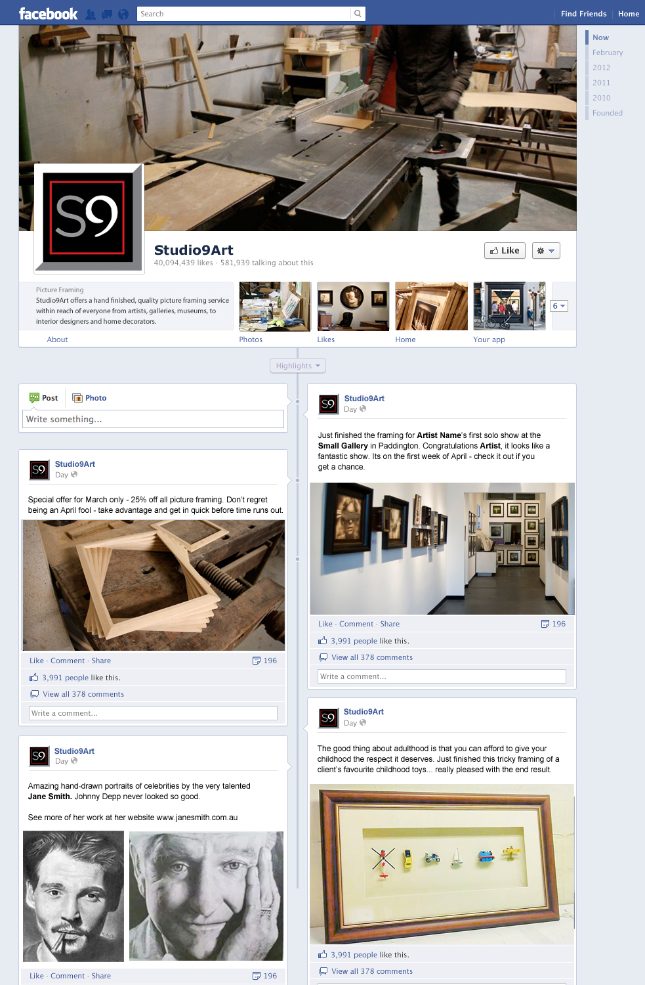

**Developing a website**

If you want to manage your own website rather than get someone to do it for you, you have a few options. You can use a blogging platform such as Wordpress or Blogger, or a website builder such as Wix or Squarespace.

You will need to research to decide which route you want to go down. All of these sites have templates that you can use to set up your website without having to learn a line of code. For the website builders, everything is mostly drag and drop, so its easy to set up. You can also change the template at any stage of your website if you want a new look.

Wix charges $4 per month for its most basic plan, Squarespace is more expensive. Wordpress and Blogger are free, but if you want a special template (there are around 100 free template) you can buy one. you also get access to more fonts and colours when you purchase a template.

Website builders are probably better if you want to just build a website and leave it at that. Blogging sites are good if you plan to update it regularly with new work. You have a facebook page already that you can use for regular updates, so probably using a website builder that links to the facebook page is the best option for you.

A review (and pricing plans) of Wix is here: <http://www.websitebuilderexpert.com/wix-review/>

You could start off on the cheapest plan and then upgrade as you need to. You own your domain already so you can use that for your site. You will need to put aside a few hours to learn the platform and set up your site. [www.wix.com](http://www.wix.com)

**Website design mockup**

Work out what you want to go on your website and plan it out on paper (called a wireframe – basically you draw a series of boxes representing your content and how you want the page to look) before you begin.

Check out the pages from competitors and work out what you like, what is useful and what isn’t.

Below is a basic mockup of a sample website. The **Services** page will outline what you do, **Gallery** will be a showcase of recent work, **News** will include things like noteworthy events you’ve been involved in, special deals, stuff like that. **Contacts** is fairly obvious, and you can include an online contact form on this page, maybe a quote estimate form.

